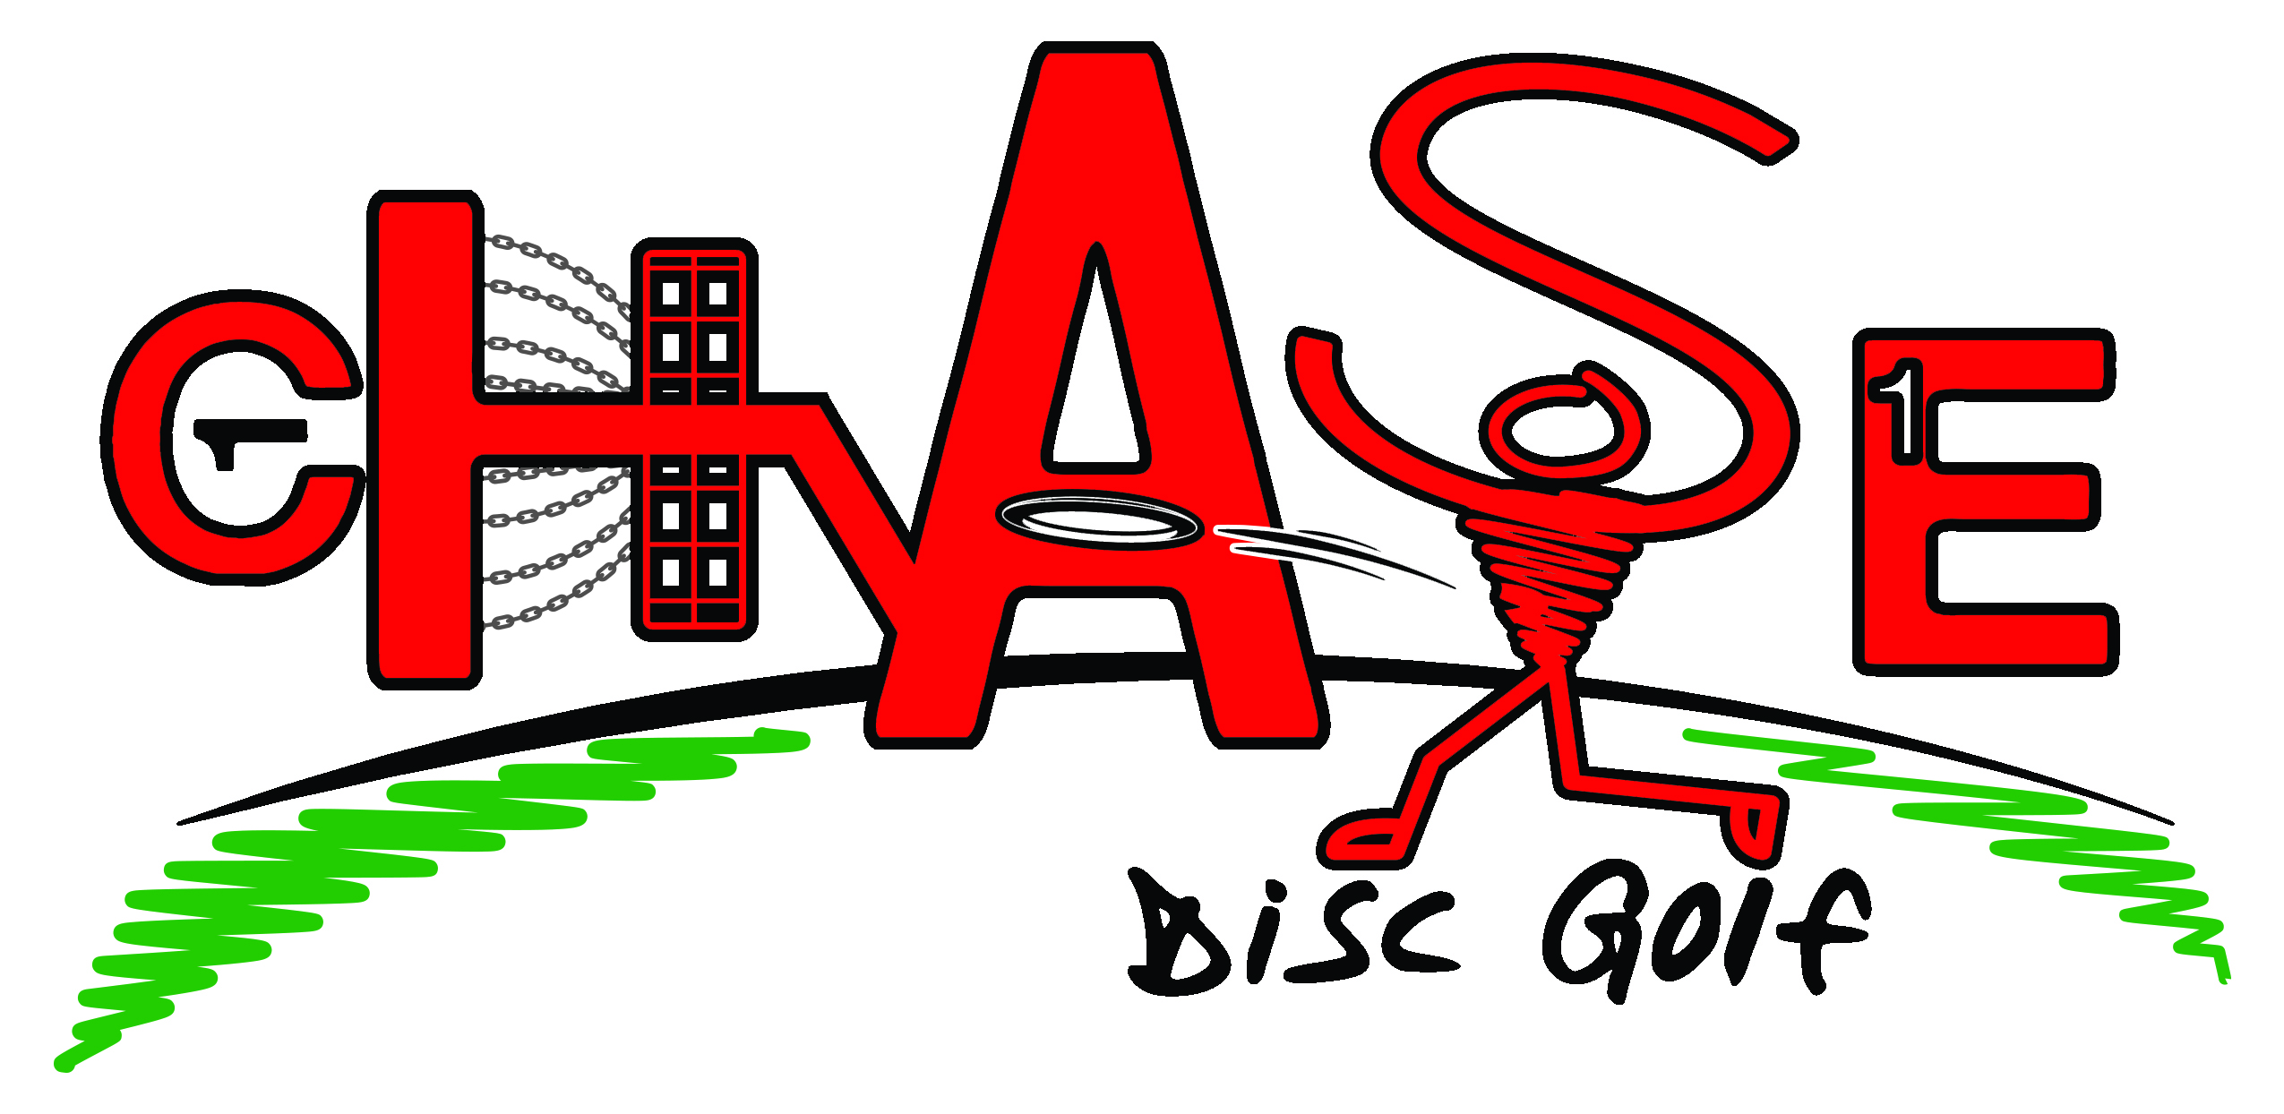

Business: _____________________________________

Contact Person: _____________________________________

Address: _____________________________________

The establishment of the Chase Disc Golf Course is an effort to continue the beautification of the City of Cottonwood Falls while enhancing the quality of life for all ages of residents by expanding the core of activities in Swope Park.

- Yes, I want to participate in the Chase Disc Golf Course project and be recognized as at Chase Disc Golf Sponsor.

- No, I do not want to be recognized as a Sponsor of Chase Disc Golf but would like to make a financial gift in the amount of $_______________________________.

Donor Levels of Recognition Gift Amounts

Supporter $ 25-99
- Listed on Official Score Card and Marketing Materials for Ground-Breaking

Patron $ 100-249
- Listed on Official Score Card and Marketing Materials for Ground-Breaking
- Recognized on the Chase Disc Golf Course Kiosk

Sponsor
- Listed on Official Score Card and Marketing Materials for Ground-Breaking
- Recognized on the Chase Disc Golf Course Kiosk
- Featured with Signage / Logo on the selected available Basket or Tee Box

Basket Sponsor $ 250
- Name and/or Logo printed on top ring of Disc Basket

Tee Box Sponsor $ 250
- Name and/or Logo printed on Tee Box Marker

Hole Sponsor $ 500
- Name and/or Logo printed on Tee Box Marker & Basket

Please provide the City of Cottonwood Falls with the appropriate name(s) and logo along with Hole / Basket preferences. _________________________________________________________
____________________________________________________________________

Signature: _______________________________________________________

Date: _____________________

C:\Users\Ridefree\Documents\Boyce\City Of CWF\Discgolfcoursesponsoragmt12.09.15.Docx

